**DM3 Firmware Build-Deploy-Test**

**Virtual Box Guide**

**DM3**



Continuous Integration

|  |  |
| --- | --- |
| Version: | 1.0 |
| Version Date: | June 20, 2016 |
| Effective Date: | June 20, 2016 |

Contents

1. REVISION HISTORY: 3

2. PURPOSE 4

3. SCOPE 4

4. SOFTWARE INSTALL INSTRUCTIONS FOR BROADCOM BUILD 5

5.1 CONFIGURATION INSTRUCTIONS – VirtualBox 21

5.1 GUEST ADDITIONS SET UP INSTRUCTIONS – VirtualBox 22

5.2 SHAREDFOLDER SET UP INSTRUCTIONS – VirtualBox 27

5.3 SOFTWARE SET UP INSTRUCTIONS – OpenSSH 31

5.4 SVN– Subversion Linux 33

5.4 SVN KEY GENERATION – SSH Putty Keys 34

5.5 SOFTWARE SET UP INSTRUCTIONS – SSH Remote Server ENV Path 42

5.6 SOFTWARE SET UP INSTRUCTIONS – SVN Subversion (version control system)Wind 44

5.7 SOFTWARE SET UP INSTRUCTIONS – CodeWarrior 50

# REVISION HISTORY:

|  |  |  |  |
| --- | --- | --- | --- |
| ***Rev.*** | ***Date*** | ***Authors*** | ***Comments*** |
| 1 | 07/3/16 | Ross Rhone  Spencer Peters | Initial Version |
| 2 | 8/4/16 | Ross Rhone  Spencer Peters | First Revision |
| 3 | 9/16/16 | Ross Rhone | Second Revision |
|  |  |  |  |
|  |  |  |  |
|  |  |  |  |
|  |  |  |  |
|  |  |  |  |
|  |  |  |  |
|  |  |  |  |
|  |  |  |  |
|  |  |  |  |
|  |  |  |  |
|  |  |  |  |
|  |  |  |  |
|  |  |  |  |
|  |  |  |  |
|  |  |  |  |
|  |  |  |  |
|  |  |  |  |
|  |  |  |  |
|  |  |  |  |
|  |  |  |  |
|  |  |  |  |
|  |  |  |  |

# PURPOSE

The Build-Deploy-Test Quick Start Guide (BDTG) is used set up the necessary software required to run the Build-Deploy-Test Program.

# SCOPE

This document is to be referred to when creating or modifying software development projects.

# SOFTWARE INSTALL INSTRUCTIONS FOR BROADCOM BUILD

**5.1 – Virtual Box**

**Required Build Tools**

* Oracle VM VirtualBox - <https://www.virtualbox.org/>
* Ubuntu-16.04 ISO File - <http://releases.ubuntu.com/xenial/ubuntu-16.04-desktop-i386.iso>

**Build Instructions**

1. Download and install Oracle VM VirtualBox (Windows (32-bit) VirtualBox-5.0.22-108108-Win.exe)
2. Start Oracle VM VirtualBox

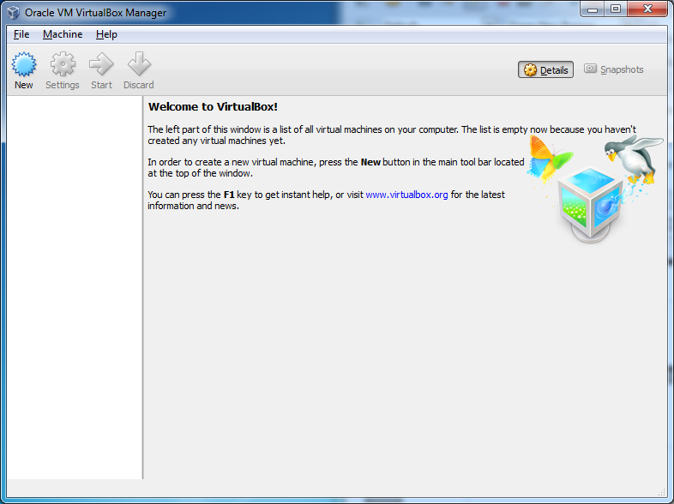

1. Create a new virtual machine. Choose Machine…New from the main menu:

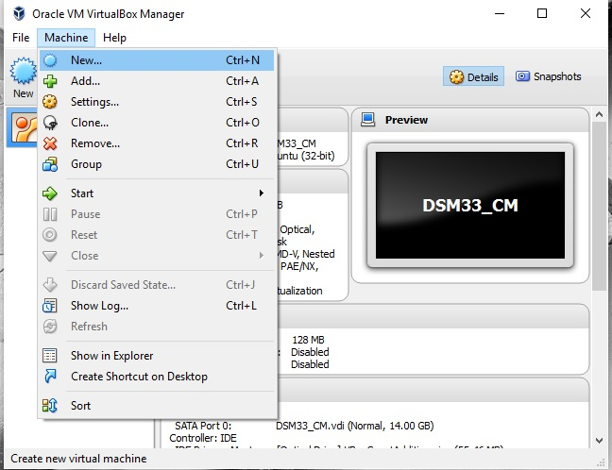

1. Configure the virtual machine’s memory. Choose an amount of RAM (“Memory size”) which is less than the total amount of RAM your computer has. Somewhere in the range VirtualBox displays as green is reasonable; we chose to assign half our RAM to the VM since half of the build is occurring in the VM. Also, select “Create a virtual hard disk now.”

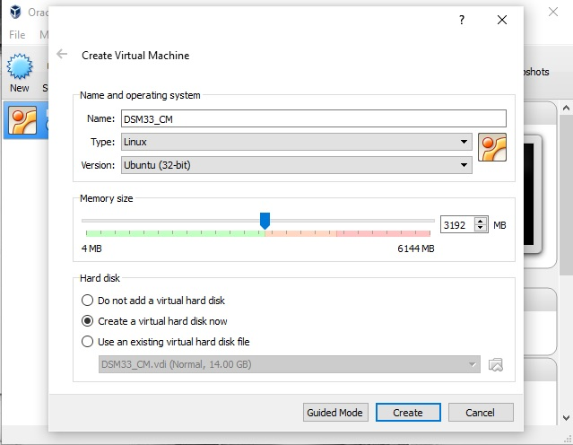

1. Configure the virtual hard disk. We chose to allocate more memory than we thought we would need, 14 GB, since hard disk space is plentiful. Also, it’s difficult to give the VM more disk space later.

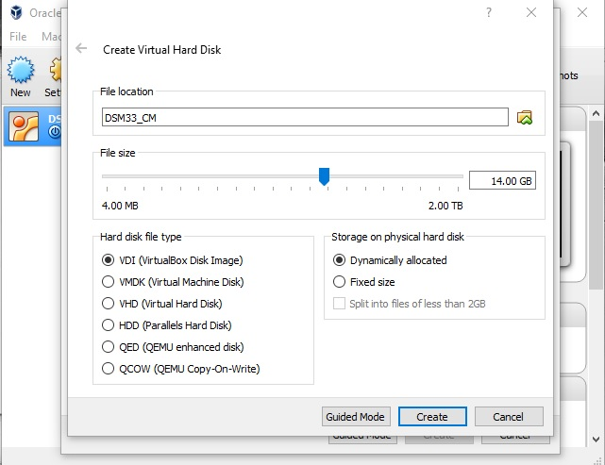

1. The DSM33_CM virtual machine is loaded:

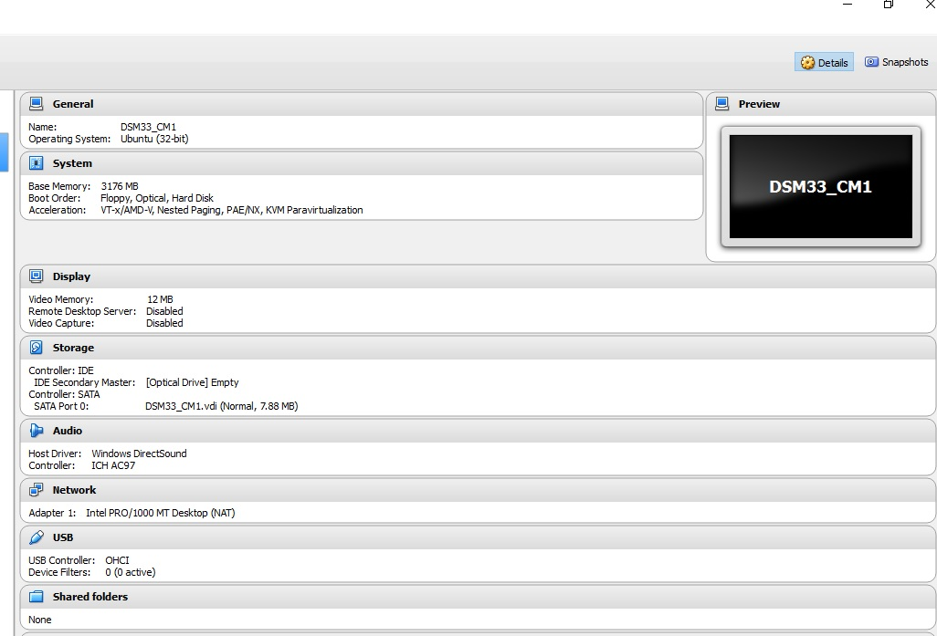

1. Click on the Settings Button … System … Processor and adjust settings according to how many CPU Cores your computer has. We chose to allocate half of the amount of available cores to the Virtual Machine. If the VirtualBox GUI displays CPU settings as locked and you cannot edit them, you may have to configure BIOS settings; refer to the next page.

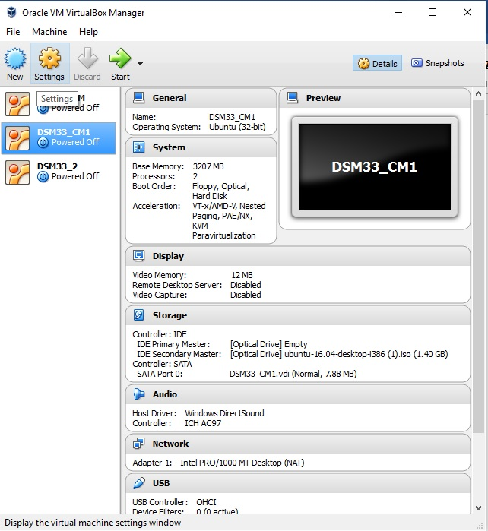

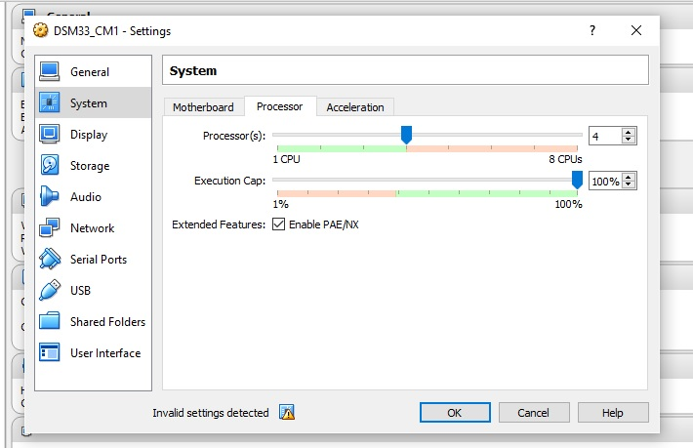

1. Proceed to read this section if you are unable to change CPU settings. The virtual machine will not be allowed to change these settings until you have enabled Virtualization Technology (also known as Intel VT) AMD-V, or SMV depending on the brand of the processor. These settings can only be set through the BIOS. You can use one of two methods of entering BIOS setup:

Method 1:

1. Press and hold the Power Button for 5 seconds to turn your computer completely off.
2. Power on the system. As soon as the first logo screen appears, immediately press the F2 key, or the DEL key if you have a desktop, to enter the BIOS.

Method 2:

1. Click the Start  menu and select Settings.
2. Select Update and Security.
3. Click Recovery.
4. Under Advanced startup, click Restart now. The system will restart and show the Windows 10 boot menu.
5. Select Troubleshoot.
6. Choose Advanced options.
7. Select UEFI Firmware Settings.
8. Click Restart to restart the system and enter UEFI (BIOS).

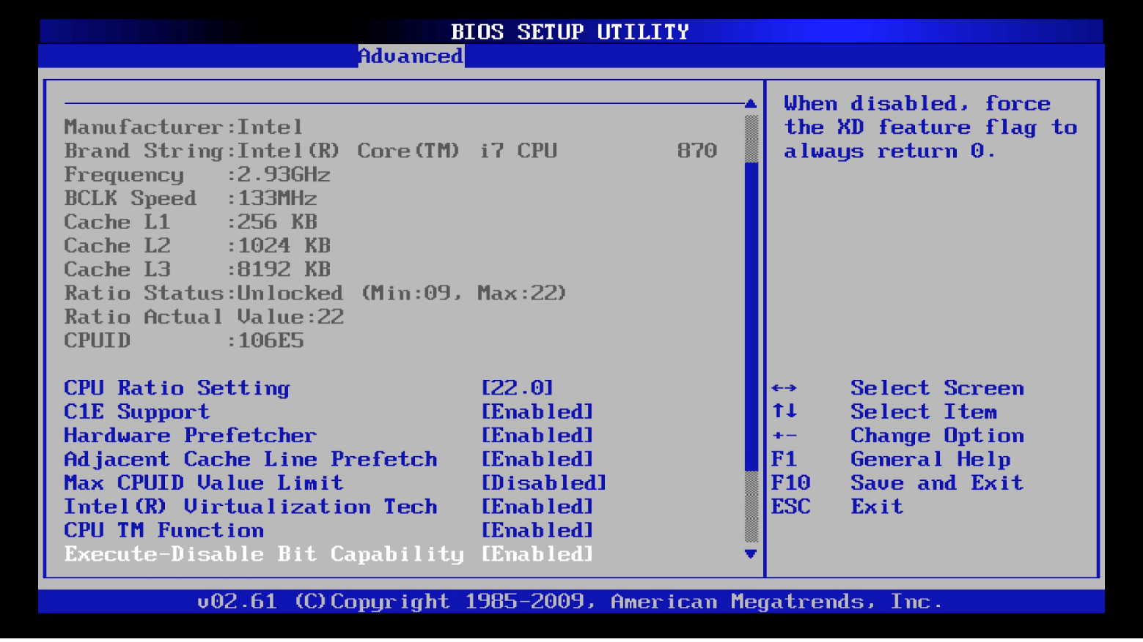

1. Download 32-bit Ubuntu-16.04 ISO: <http://releases.ubuntu.com/xenial/ubuntu-16.04-desktop-i386.iso>. Click on the Settings button … Storage …Set up IDE Controller with a Virtual Optical Disk File. Select the Ubuntu-16.04-desktop-i386.iso file that you just downloaded. This is very much like dropping an Ubuntu optical disk into the actual optical disk drive of a blank machine with no operating system on it.

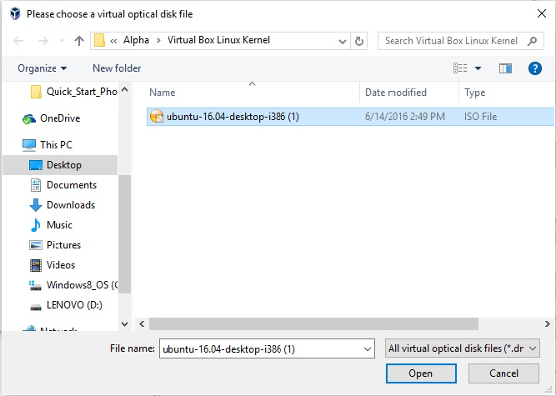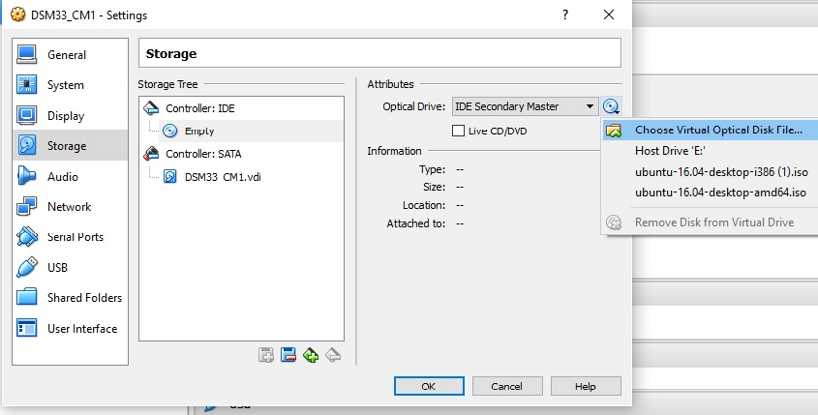

1. DSM33_CM virtual machine finalized settings:

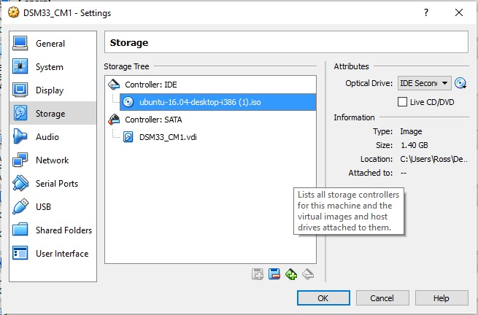

1. Click the Start button to run the new DSM33_CM virtual machine:

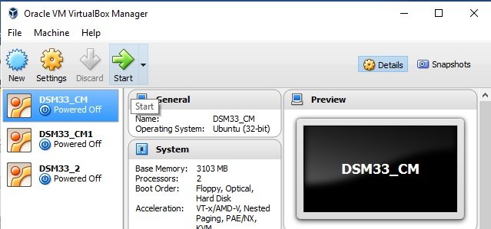

1. Ubuntu Install Screen, Select Install Ubuntu:

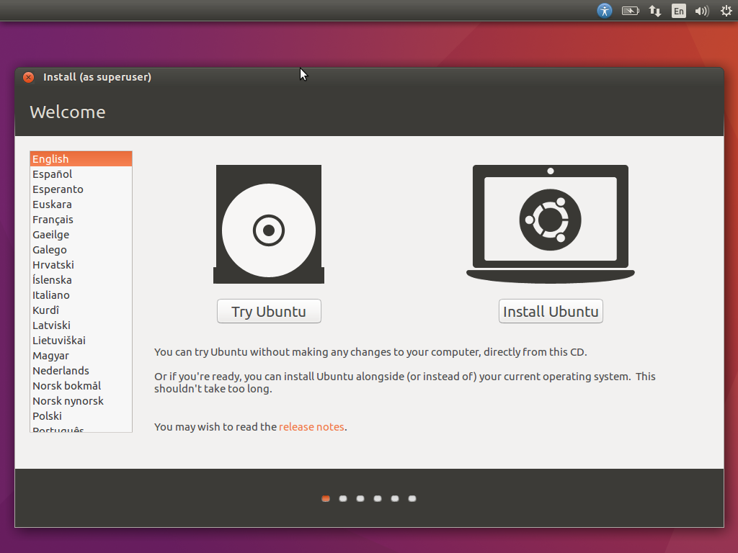

1. Select Download updates while installing Ubuntu and Install third-party software. Click on continue button:

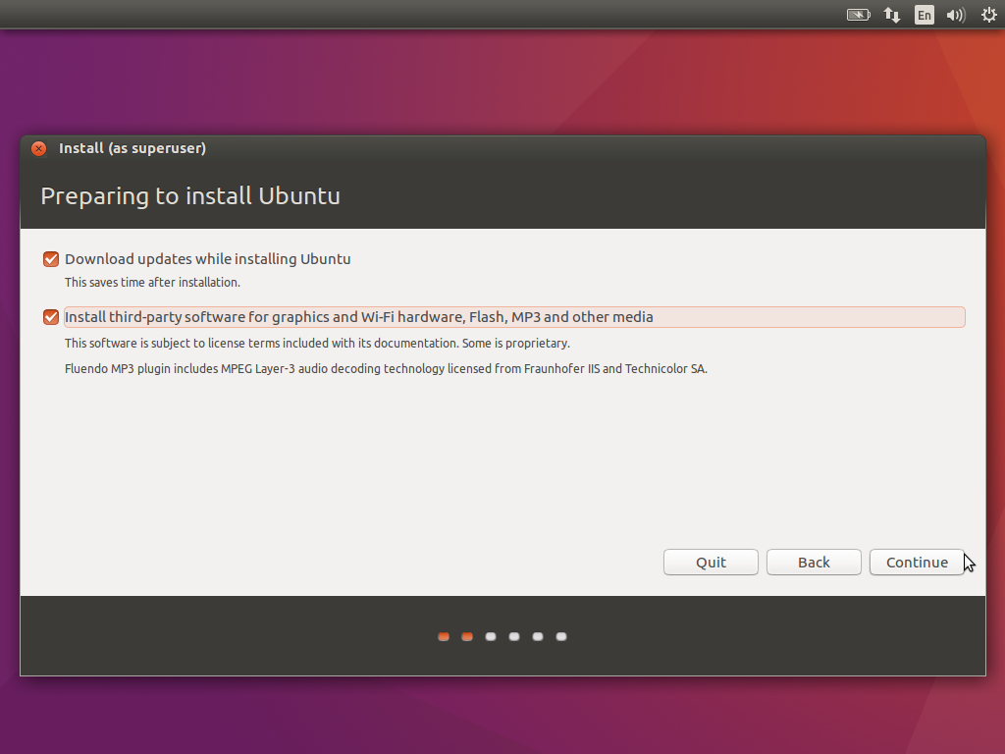

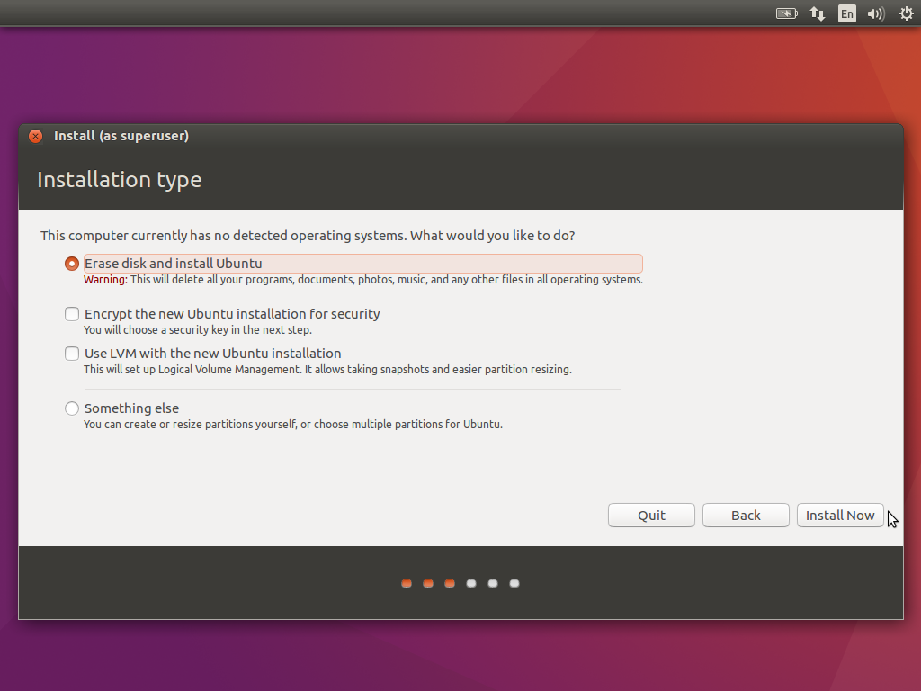

1. Select Erase disk (your virtual disk is in fact already blank), and install Ubuntu.
2. Select Keyboard layout for English (UK):

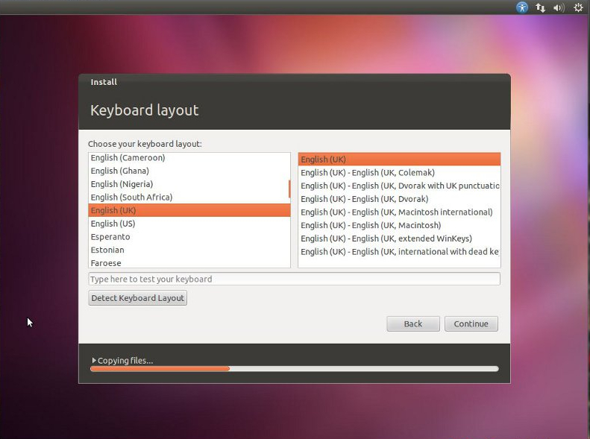

1. Set up your login creditionals for Ubuntu:

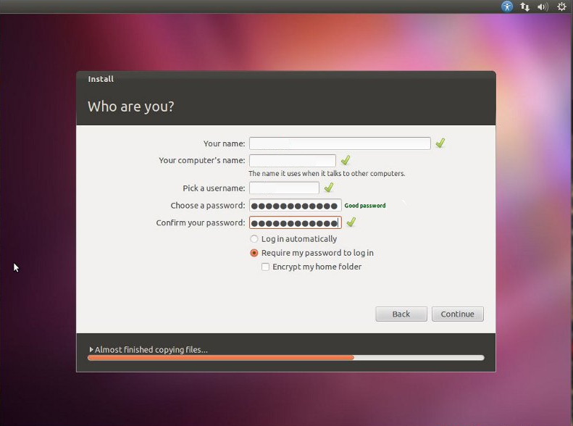

1. Installation has complete and needs to restart in order to run. Click on restart Now button:

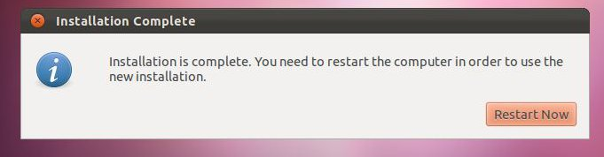

# 5.1 CONFIGURATION INSTRUCTIONS – VirtualBox

1. Allow commands to be run as root with sudo without entering the current user’s password. This makes life easier for our scripts.
2. Run sudo visudo:
3. Scroll down with the arrow keys to the end of the file and type the following command:
   1. <yourLinuxUsername> ALL=NOPASSWD: ALL. Example below.

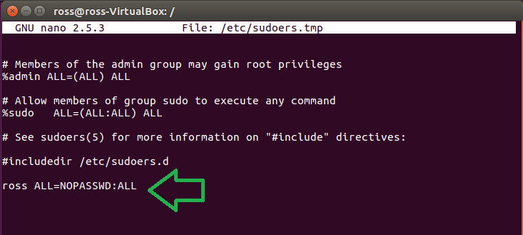

1. Ctrl + O to save changes. Ctrl + X to exit nano.
2. Reboot your VM “Virtual Machine”. The following command should not ask you for a password after you log back in “sudo echo test”

# 5.1 GUEST ADDITIONS SET UP INSTRUCTIONS – VirtualBox

* Summary: Install setup for sharedfolders/clipboard access between guest (linux virtual box) and host (windows) computers.

**Required Build Tools**

* Oracle VM VirtualBox - <https://www.virtualbox.org/>

**Build Instructions**

1. Go back into the virtual box settings, click on Storage, click on the CD under Controller: IDE that says Empty go over to the right hand side to the Optical Drive and click on the CD icon and click on the tab that says Choose Virtual Optical Disk File.

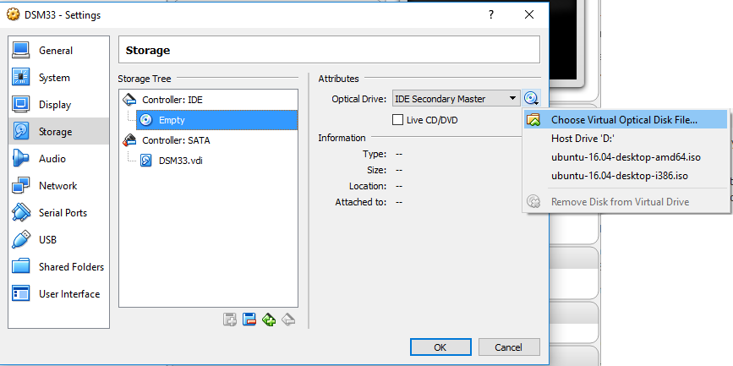

1. Find the location of where you installed the Virtual Box folder. From there select VBoxGuestAdditions.iso. (example C:\Program Files\Oracle\VirtualBox) continue to click ok again in the virtual box settings.

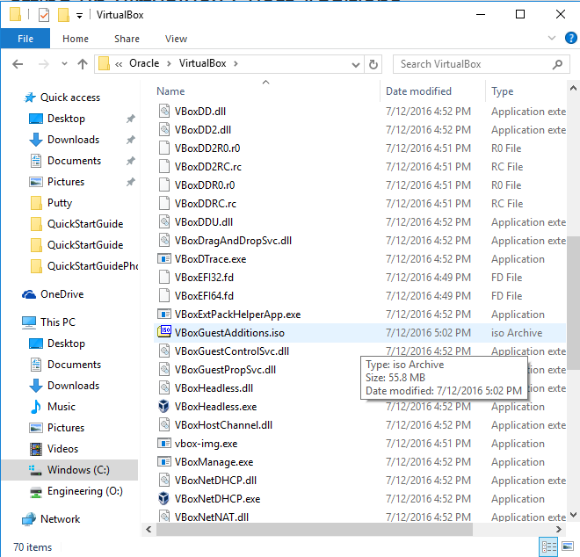

1. Start up your linux session again and open up the terminal by (ctrl + atl+ t) or clicking on the white circle icon and searching terminal.

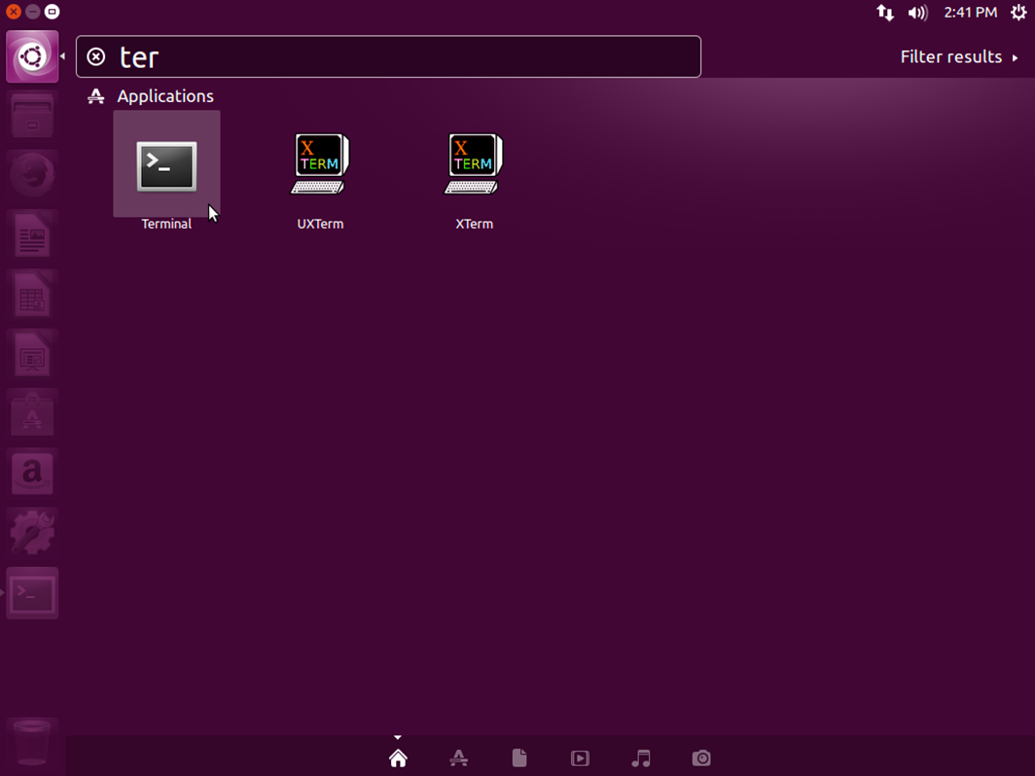

1. Inside the terminal write the following commands. sudo apt-get install virtualbox-guest-additions-iso. Sudo (super user) will ask for the user’s password.

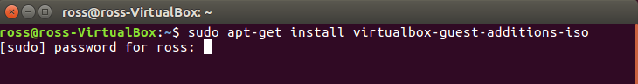

1. After a successful install your screen should look like this.

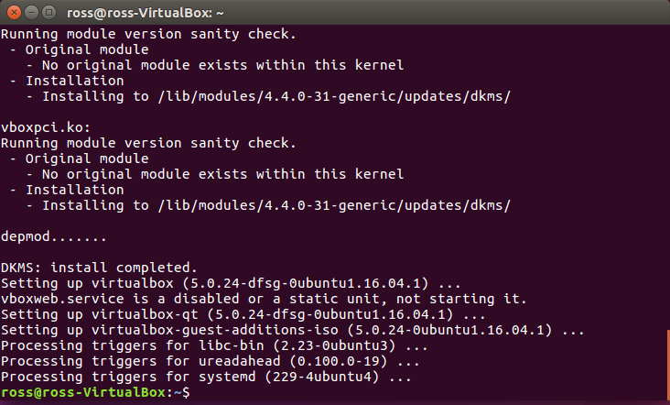

1. There will now be a folder called VBOXADDITIONS

(example /home/ross/media/ross/ VBOXADDITIONS ) and inside of it will be a shell script install file that you will need to run with the following command ./.

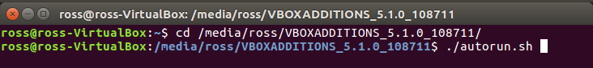

1. After the install is finished you should see this screen.

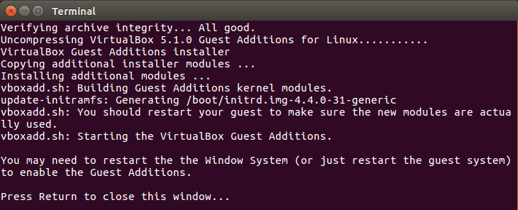

1. Test the guest additions by clicking on the Devices tab in your virtual box and click on the slot Shared Clipboard… Bidirectional. You should now be able to copy and paste from the host computer (windows) and the guest computer (linux virtual box).

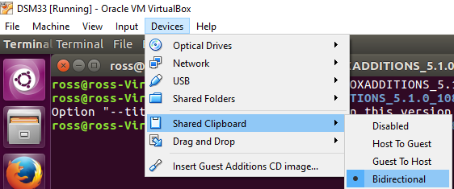

# 5.2 SHAREDFOLDER SET UP INSTRUCTIONS – VirtualBox

* Summary – Set up shared folder. We’ll use this folder for SSH key transfer during SSH install, and for transferring finished Broadcom binary on each build.

**Required Build Tools**

* Oracle VM VirtualBox - <https://www.virtualbox.org/>

**Build Instructions**

1. Configure the shared folder in VirtualBox. Graphically, go to Devices >> Shared Folders and open the Shared Folders wizard.

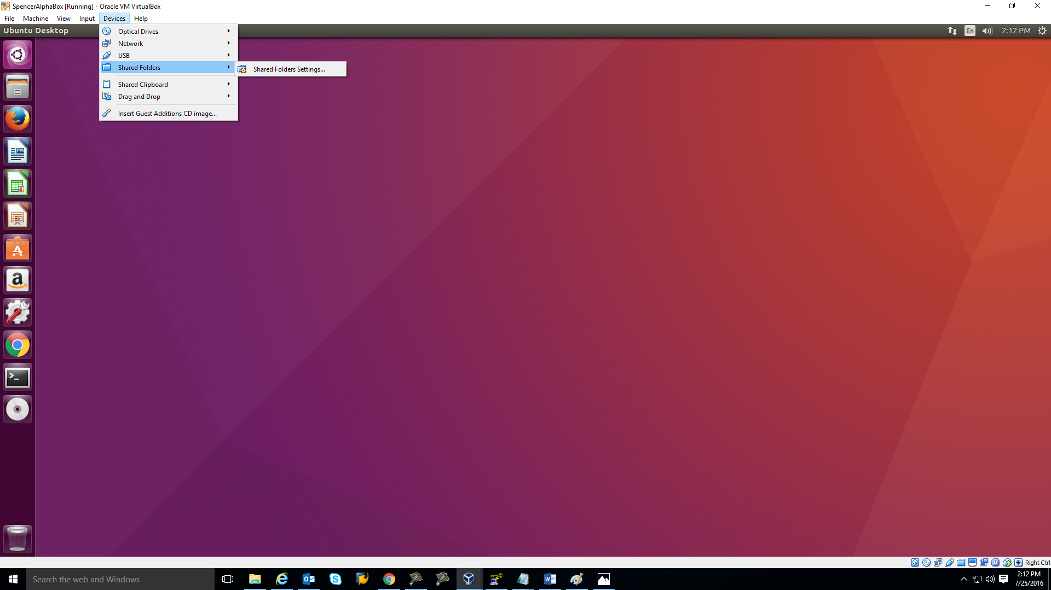

1. Click the blue folder icon to make a new shared folder.

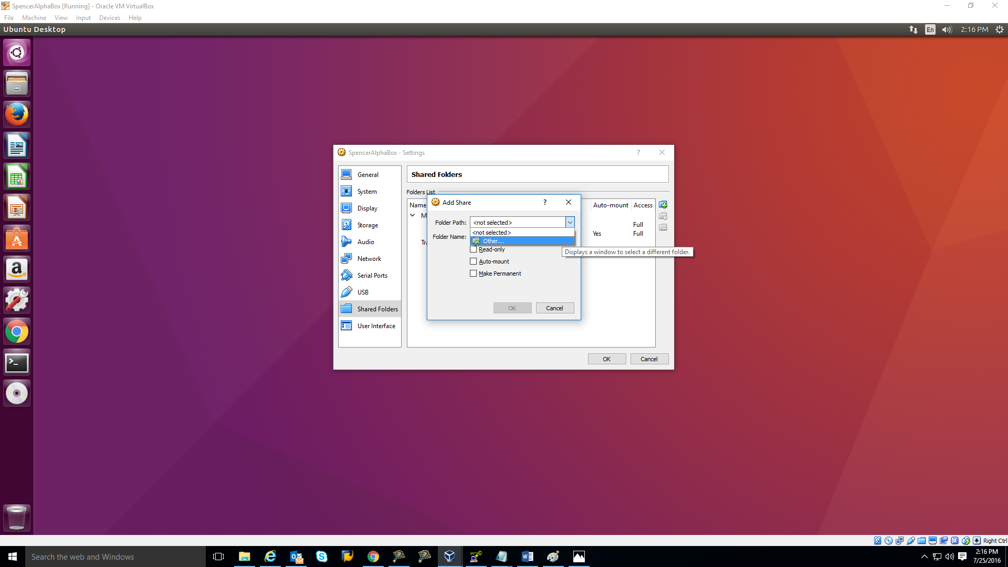

1. Click the arrow at right of the Folder Path field, click Other, then use the File Explorer to find the directory you’d like to put the shared folder in. Make and name a new folder in this directory, then hit Select Folder.

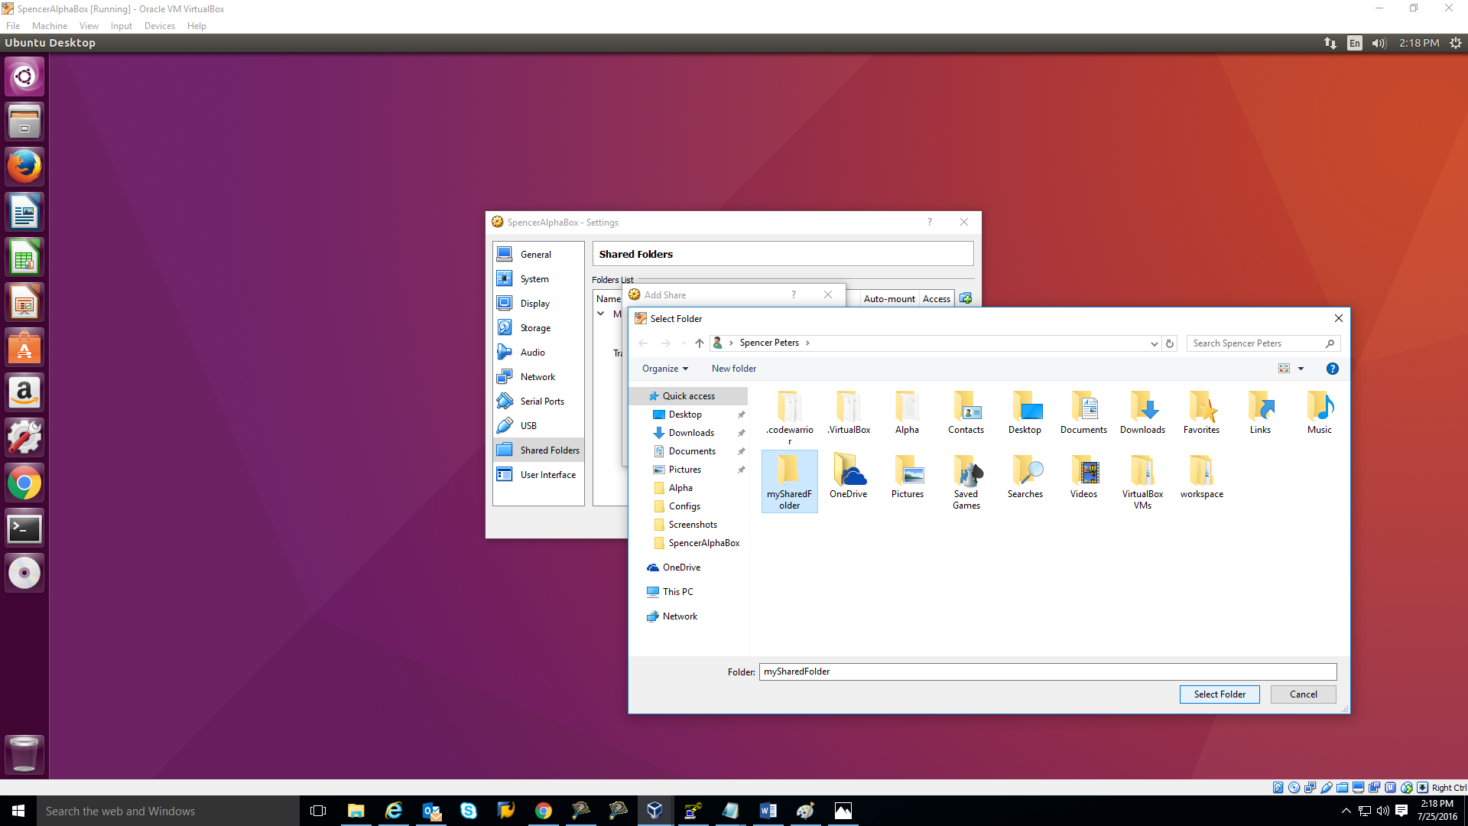

1. Select Make Permanent and Auto-mount so that the folder persists when you reboot the VM.

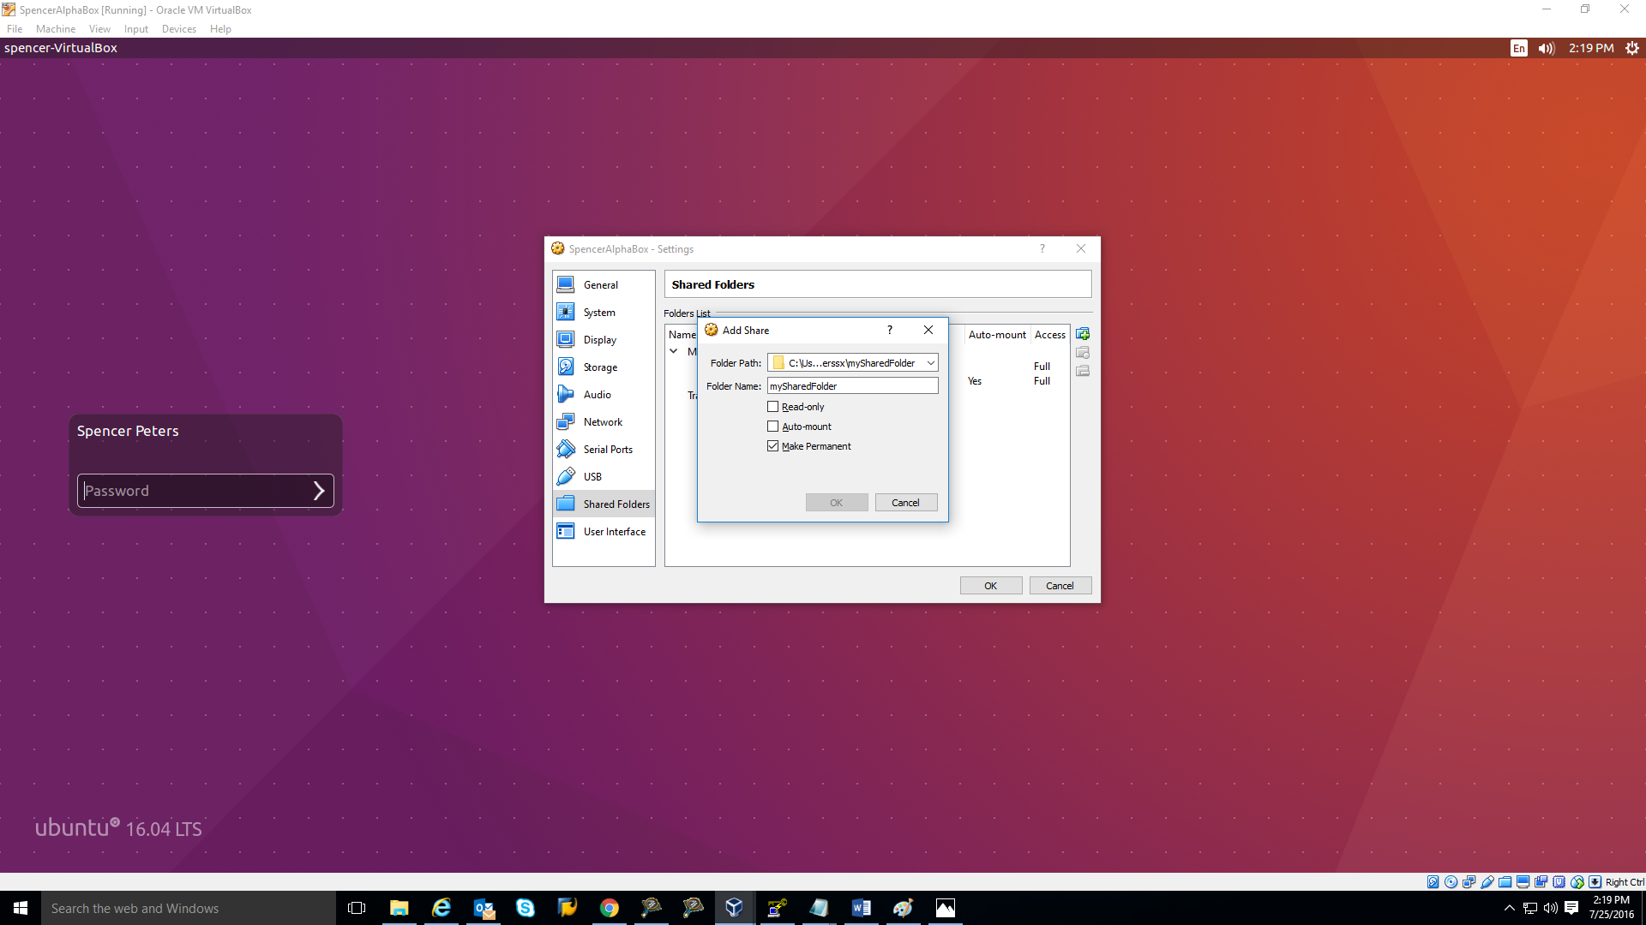

1. Note the shared folder name, in this case mySharedFolder will be named is sf_mySharedFolder in the media directory “/media/sf_mySharedFolder” **NAMING MATTERS**.
2. Finally—this is important—add your linux user to the group that is allowed to access VirtualBox shared folders. Execute this command:
   1. sudo usermod –a –G vboxsf yourLinuxUsername
3. Then restart the VM.
4. **OPTIONAL:** If you need to reconfigure the way VirtualBox saves shared folders—change the mount directory from /media or the folder prefix from sf_--see [Section 4.7 of the VirtualBox manual.](https://www.virtualbox.org/manual/ch04.html#sf_mount_auto)
5. **OPTIONAL:** You can also temporarily mount the shared folder in a new location with
   1. sudo mount -t vboxsf mySharedFolder /path/to/mount

# 5.3 SOFTWARE SET UP INSTRUCTIONS – OpenSSH

* Summary – OpenSSH will be used for easy access of controlling the guest computer from the host computer.

**Required Build Tools**

* Virtual Box Installed

**Build Instructions**

1. Start your terminal.

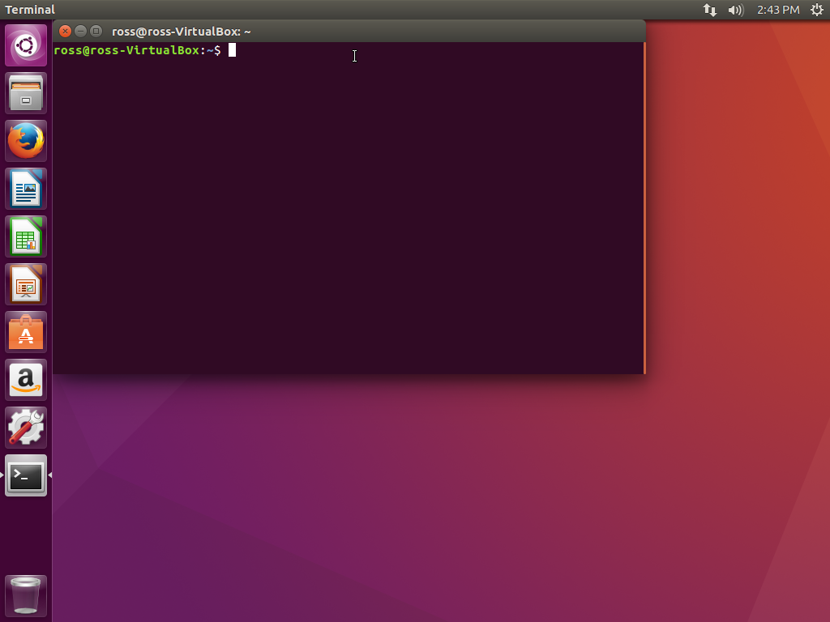

1. Download and install the OpenSSH Server by typing this following command in the terminal.

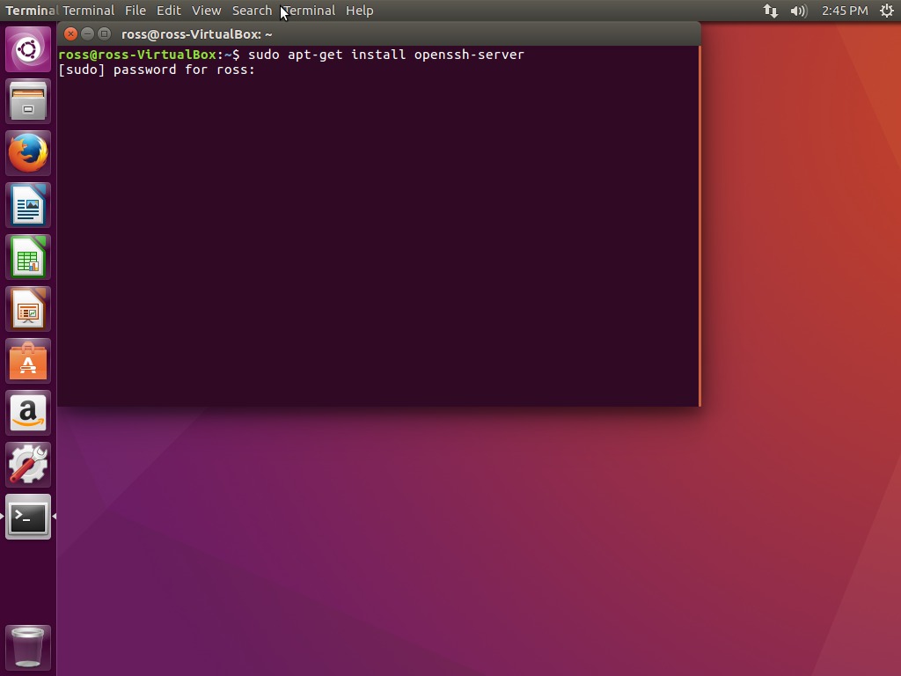

1. Once installed, make a directory for the keys you’re about to generate:

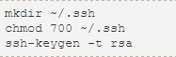

# 5.4 SVN– Subversion Linux

* Summary – Will set up subversion to access Broadcom source code for the linux.

**Required Build Tools**

* Virtual Box Linux

**Build Instructions**

1. Run the following command from the terminal to install subversion.

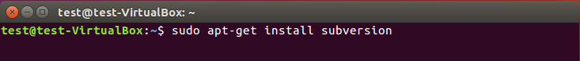

1. The following output will be as follows below:

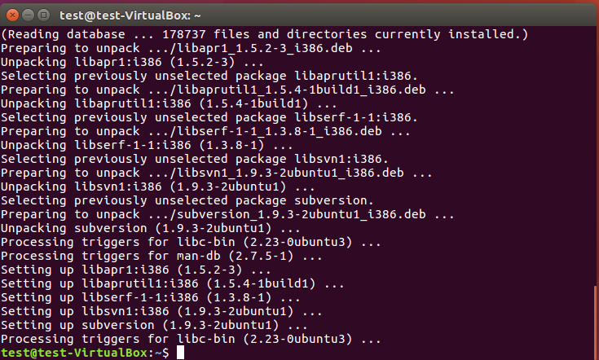

# 5.4 SVN KEY GENERATION – SSH Putty Keys

* Summary – The putty tools will be used to generate an automatic SSH connection between the guest machine and host machine without always asking for a user name and password.

**Required Build Tools**

* Putty.exe – <http://www.chiark.greenend.org.uk/~sgtatham/putty/download.html>
* Puttygen.exe
* Plink.exe

**Build Instructions**

1. Install the required Putty Binary files listed up above. We recommend downloading the .zip file with all the Putty binaries; everything is available [here](http://www.chiark.greenend.org.uk/~sgtatham/putty/download.html).
2. Log into your Virtual Box and open up a terminal and run the following command “ifconfig” to find your virtual’s box local host IP “inet addr” highlighted below. (Note: this is very likely 127.0.0.1. @Reviewer: is it worth looking—are there circumstances where this would not be the address?)

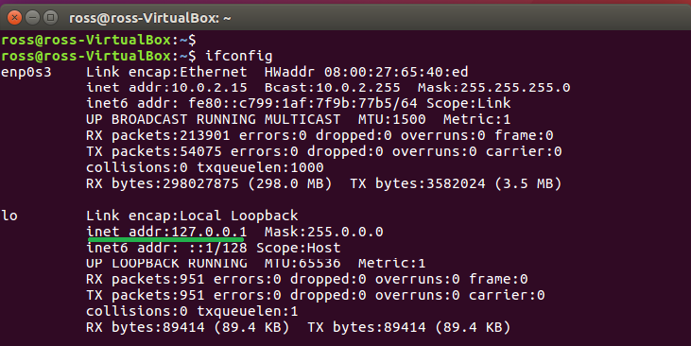

1. Open up VirtualBox Manager, click on the Settings tab, click on Network, and edit the Adapter 1 settings. Set Attached to: to NAT. Then click Port Forwarding.

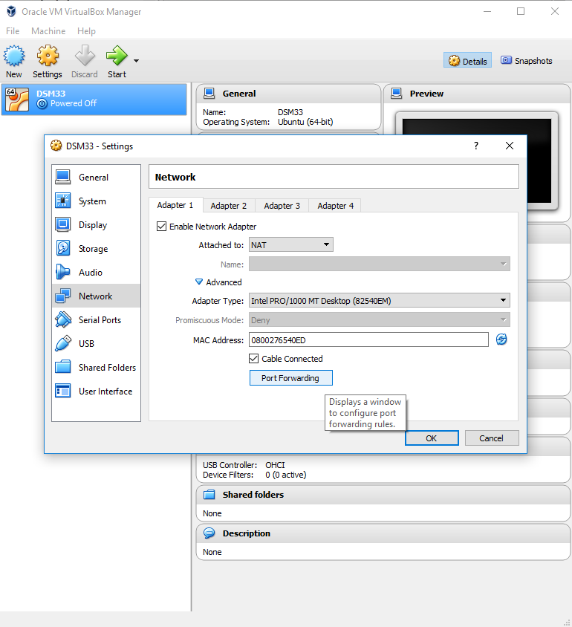

1. Add a new Port Forwarding Rule as follows: Protocol – TCP; Host Port – 2222; Guest Port – 22. This resolves issues having to do with the same port being used in two different places on the same machine—we think it’s likely that there are many other ways to accomplish this fix.

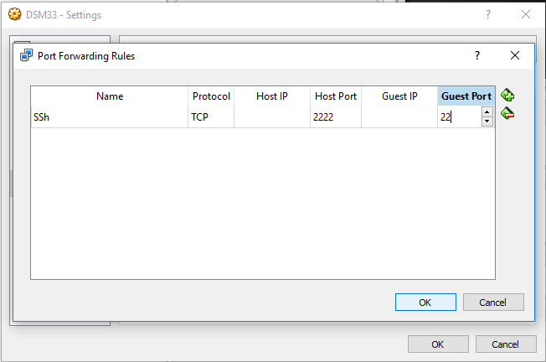

1. Go back into Windows and run PuTTY Key Generator and click on the Generate key tab.

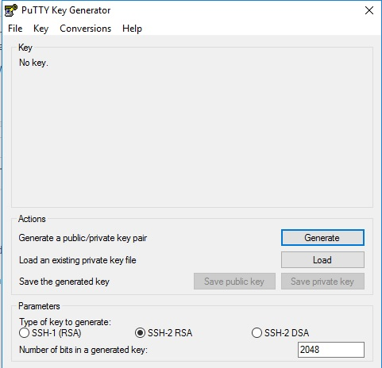

1. Once you have randomly generated your key, save your private key in a desired location. The file extension should match below .ppk.

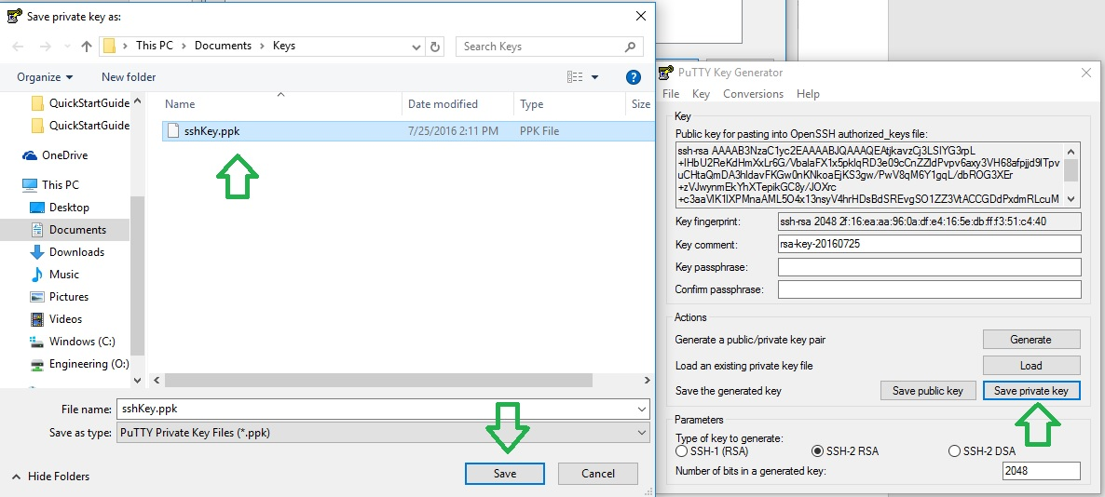

1. Copy the public key from the PuTTY clipboard.

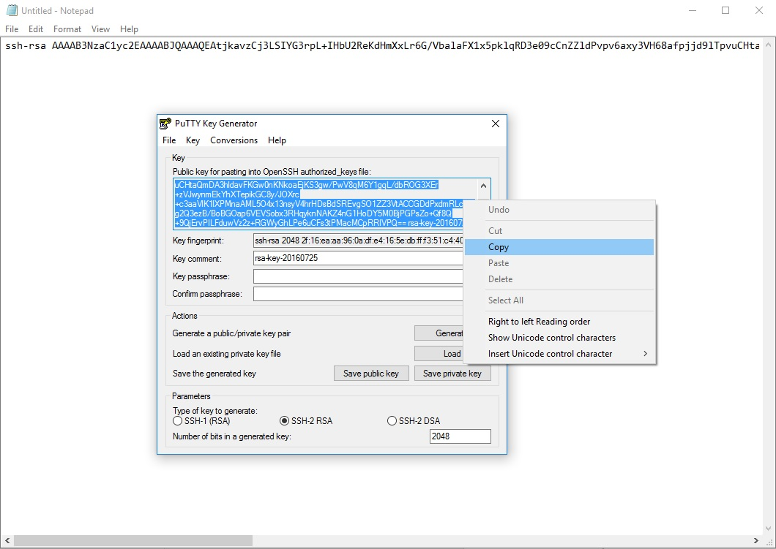

1. Open gedit in the VM; paste the public key into gedit.

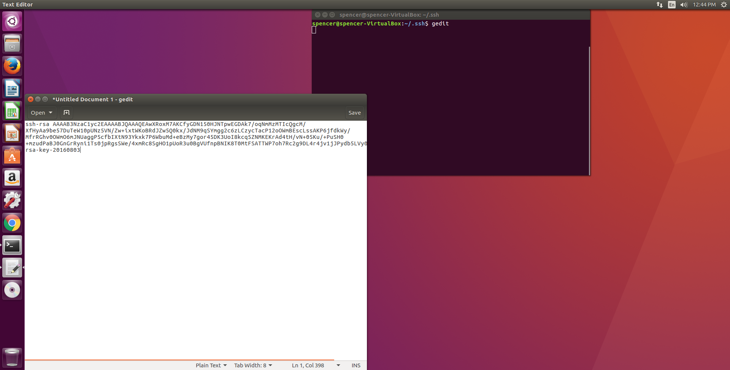

1. Save the resulting file in ~/.ssh. Name it authorized_keys. Then run
   1. chmod 700 authorized_keys.
2. Test your connect with SSH by running the following command in your windows command prompt
   1. To test your connection, run the command-line SSH tool plink from WINDOWS CMD. Use
      1. –i to give it your private key
      2. –P with the port number you made the forwarding rule with above
      3. Your linux login, with the local IP address you obtained from ifconfig
      4. And some basic command to run. The output from this command will be routed back to CMD.



# SOFTWARE SET UP INSTRUCTIONS – SSH Remote Server ENV Path

* Summary – When accessing a command through SSH to a remote server it is considered Non-interactive. Your environment variable path will not be set the same as your interactive session (ex. The shell can prompt the user to enter input) Therefore we must set the PATH to match for both sessions. ~/.profile (interactive) & ~/.bashrc (non-interactive)

**Required Build Tools**

* SSH Connect established

**Build Instructions**

1. Open up the terminal and locate/edit the following file: /etc/ssh/sshd_config running as sudo.

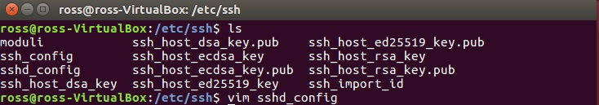

1. Add the following command in: PermitUserEnvironment yes at the end of the config file.

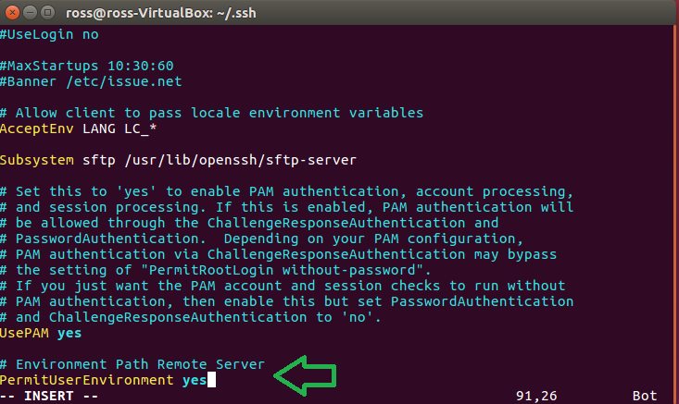

1. Locate/edit the following file: ~/.ssh/environment if there file is not already created please do so.

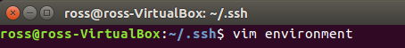

1. Add your current path to this file. Very important to have the correct file paths for zOEMtools_eCos. **IMPORTANT** (Last path is dependent on Version checked out!)

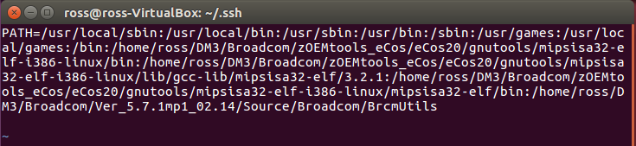

1. Restart the SSH services by using the following command: sudo systemctl ssh .



1. Repeat steps D with ~/.profile (interactive environment) file in the home directory.



1. Below in the green box is the following edits that should be made to your ~/.profile file.

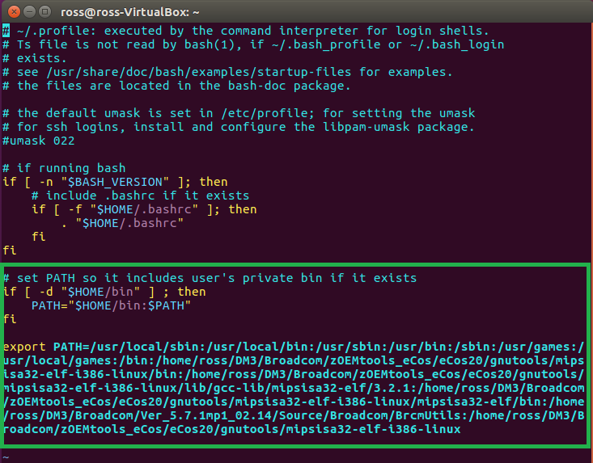

# SOFTWARE SET UP INSTRUCTIONS – SVN Subversion (version control system)

* Summary – The SVN tools will be used to download the Freescale code from the repository onto the Host computer/Windows.

**Required Build Tools**

* SVN slik - <https://sliksvn.com/download/>

**Build Instructions**

1. Download and install SVN slik (Windows (32-bit/64-bit) SVN 1.9.4
2. Once you have downloaded SVN slik you must set up the PATH for svn.
3. Type Settings in the Start  menu and when opened up click on System setting.

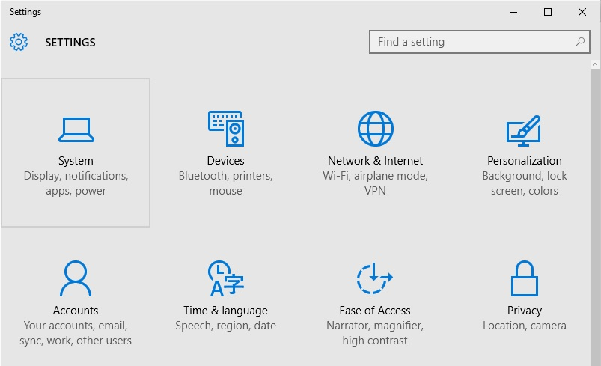

1. On the left hand side click on the tab “About” … right hand side click on tab System info.

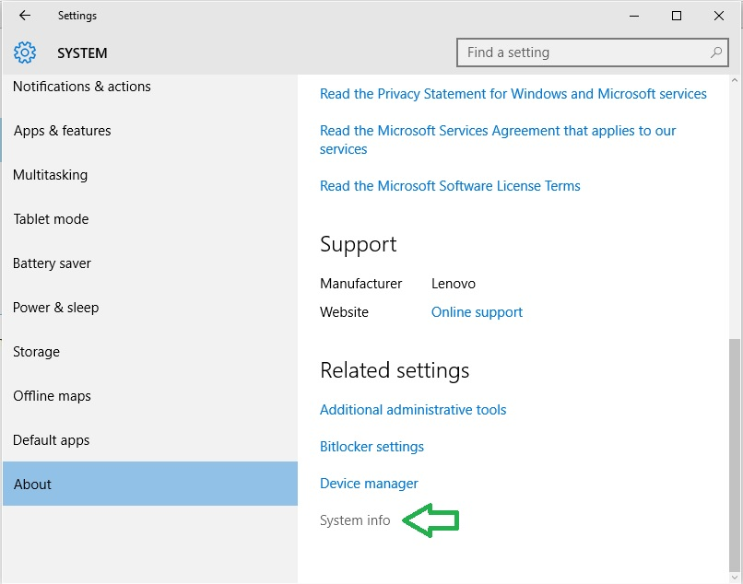

1. 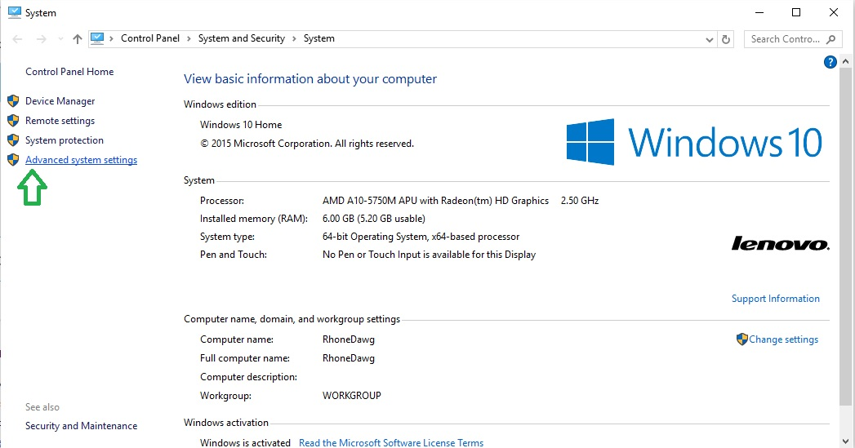Click on Advanced system settings on the left hand side.
2. Under the Advanced tab, click on Environment Variables…

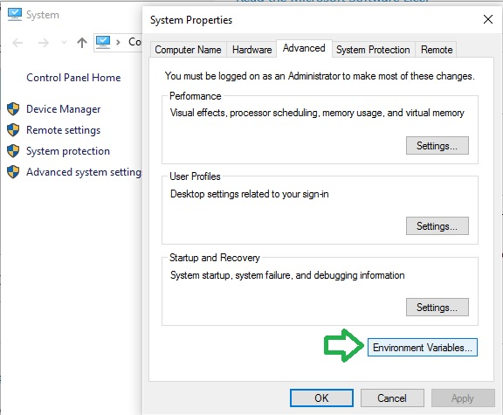

1. Go to System variables, click on the variable Path, and click the tab edit when highlighted.

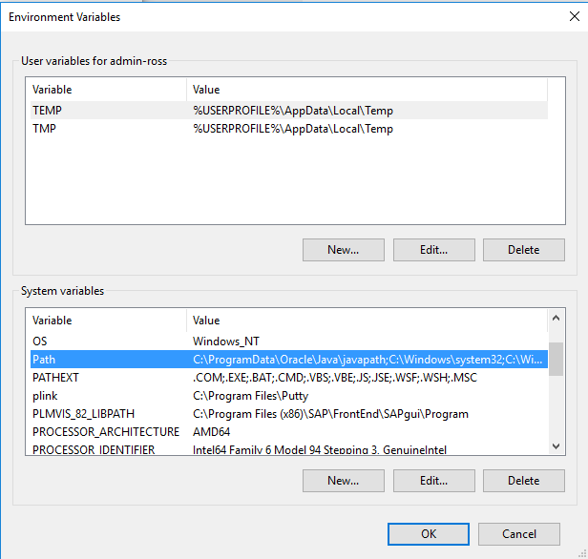

1. Click on new and enter in the locations of the files that you download for svn and putty. Example “C:\Program Files\SlikSvn\bin” and “C:\Program Files\Putty” is where I stored svn.exe and plink.exe

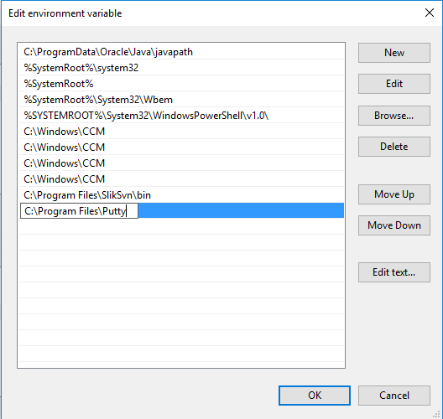

1. Your path should look similar to this. Click OK. Your path has now been set.
2. Please repeats steps above, but for “VBoxManage.exe”, which can be found in default folder if downloaded default settings “C:\Program Files\Oracle\VirtualBox”. This will give access to all of the virtual box’s command line commands.